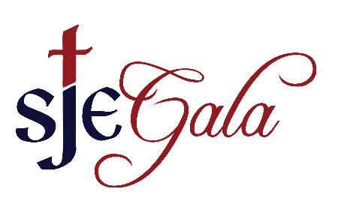
July 22, 2018

Dear Community Business Partners and Families,

The Saint John the Evangelist Catholic Parish and School is gearing up for its annual benefit and auction. If you have supported us in the past, thank you! We come to you seeking support for our 2018 Benefit Gala, at the Sister Carolyn Hoying Gymnasium on the Saint John the Evangelist Campus. This year’s event will include dinner, casino games, Masquerade Ball along with our silent and live auctions. The event will be held on Saturday, October 20, 2018 for a fun evening of community building while supporting Saint John’s Parish and School.

The benefit gala is one of our largest fundraisers of the year. It is with support from individuals and companies like yours that enables Saint John’s to continue to serve our ministries and programs which enrich our faith community. Enclosed is an auction donation form or you may choose to fill out our online donation form. Please provide as much detail as possible so we can describe your donation accordingly in our catalog. You might also consider increasing the value of your donation so we can make this year’s auction the most successful ever.
Popular auction items in the past include:

• Crafts, Gift Baskets and Homemade Items
(Unused items ONLY)
• Artwork
• Sports Memorabilia
• Sporting/Arts/Cultural Event Tickets
• Vacation Getaways
• Jewelry
• Gift Certificates

We hope you will be a part of the benefit gala by contributing an auction prize/item. We are happy to accept any item or certificate you may want to donate. St. John the Evangelist Catholic Parish and School are indispensable fixtures in our community, having greater than 2,300 families. St. John’s has a tradition of providing opportunities for spiritual growth and education for over 150 years. We appreciate your continued support in your efforts to strengthen our parish community by contributing to this exciting event. With your donation, you will expose your business to many, if not all, of these supportive parishioners and their families.
We thank you in advance for your patronage and generosity. For more information, please contact Liz Dudek and Stacey Bahre at gala@saintjohns.net or visit our website at www.saintjohnsgala.com. All donations need to be received by October 5, 2018. We look forward to hearing from you.

Sincerely,
The Saint John’s Gala Committee

Saint John the Evangelist 2017 Benefit Gala
Saturday, October 20, 2018
Auction Item Donation Form
Contact Information:
Donor Name: ________________________________________________
Address: _____________________________________________________
City: ______________________ State: ___________ Zip: _____________
Web Address: _________________________________________________
Contact Name: ________________________________________________
Contact Phone: ____________________ Email: ______________________

ITEM DESCRIPTION FOR CATALOG PLEASE TYPE OR PRINT:(please be as specific as possible, include any restrictions, expiration dates or sizes.)
________________________________________________________________________________________________________________________________________________________________________________________________________________________________________________________________________________________________________________________
Estimated Value $________________
We are accepting items NOW until October 5, 2018.

I will deliver I will mail Gala to pick-up (Date___________________)

Certificates are necessary for service-oriented items.
Certificate is enclosed Certificate will be sent Gala should make certificate
Mail completed forms to:
Saint John the Evangelist
2018 Gala
1730 W. 12th St.
Loveland, CO 80537

For more information about donation opportunities, contact Liz Dudek and Stacey Bahre at gala@saintjohns.net
* Saint John the Evangelist is a 501(c)(3) nonprofit organization.
Your donation is deductible to the full extent of the law.
Please contact Ashley Stevenson in the SJE School Business Office for your tax deductible form at 970-635-5830.

